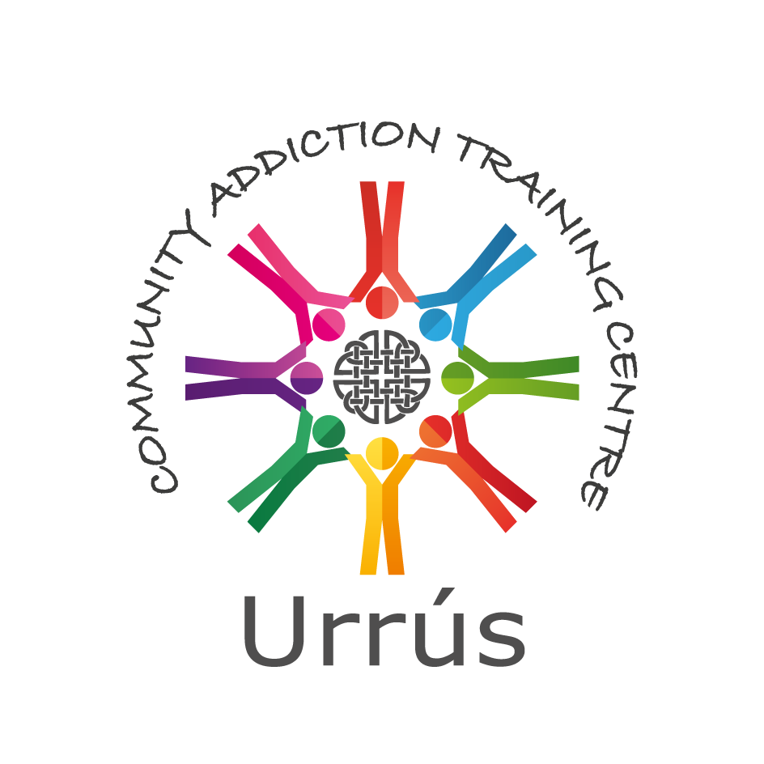

Horizons Centre, Balcurris Road, Ballymun, Dublin 11, D11 X2EP. Phone: 01 8467980 Fax: 01 8467981

Email: urrus@byap.ie Web: [www.byap.ie](http://www.byap.ie)

**Community Addiction Studies Course©**

**QQI Award (Minor) Level 5**

**Duration:** 20 weeks (one session each week)

**Organisation of Programme:** Part-time (The programme will run over 20 weeks - 1 morning each week). This programme is ideally delivered using face-to-face class activities; however, during the current pandemic the extent to which face-to-face class activities can take place will be limited and guided by Government advice. Therefore, for now the programme will be delivered in a blended learning format consisting of a combination of online sessions and real time class-based activities using either a virtual or classroom environment. Prospective learners need to be available to engage in learning and study for the dates and times indicated.  It is essential that learners have computer and internet access to engage with the course learning. Staff and learners are urged to exercise caution and continue to follow the public health guidelines rigorously

# Aim of Programme

The purpose of the Community Addiction Studies Course© is to enable people to:

* Learn about drugs and their effects
* Develop an understanding of addiction
* Explore how addiction impacts individuals and families
* Examine their own attitudes
* Become more effective in their personal responses
* Develop the skills and knowledge to become more effective in responding to drug misuse in their own communities

**Learner/Student Profile:** Community members who feel they would like to be more effective when it comes to drug/alcohol issues. To be part of this course applicants should have one module at level 4 and/or relevant work/volunteering experience, also show a willingness to learn.

**Number of Learners/Students:** 18-20 per course.

**Application/Selection Procedure:** Application form must be completed and applicants are required to take part in an interview. Application Committee selects participants based on completed application and interview. Appeals can be addressed to the Urrús Co-ordinator.

**Certification:** Urrús is registered with QQI (Quality and Qualifications Ireland). On successful completion of the programme learners will receive a component certificate in Community Addiction Studies (5N1834) QQI Award (Minor) Level 5 - Further Education and Training.

**Cost:** Category 1 - €200.

Category 2 - Ballymun Local Drugs Task Force Area - €70.

**Protection for Learners Policy:**

In the event that Urrús fails to provide the programme and certification as outlined above all payments will be refunded; financial policy and procedures available on request.

**Course Dates / Time:** Dates and time to be confirmed.

**Course Structure:** Introduction

Drug use, misuse and abuse

Drugs as participants encounter them, signs and symptoms

Drugs used in participant’s community and their effects

Attitudes

Pharmaceutical information on drugs

The process of addiction

Families and the effects of addiction on families

Interventions at a one to one level

Intervention strategies

Intervention and listening skills, role play

Personal development

Referral and treatment programmes

Agency visits

Community responses to problem drug use

Research presentations

**Methods:** Delivery of the programme is underpinned by the principles of adult education and community development.

**Application forms available on:** <http://www.byap.ie/casc-information-sheet-and-application-form>

Please answer all questions.

***Community Addiction Studies Course©***

***Application Form - Ballymun CASC 2021***

|  |  |  |  |
| --- | --- | --- | --- |
| **Name:** |  | **Phone No.** |  |
| **Address:** |  |  |  |
|  |  | **Email** |  |
|  |  |  |  |
| **Post Code:** |  |  |  |

1. Do you work in the community? Are you involved in any community activity? Please describe…

|  |
| --- |
|  |

2. How did you hear about the course?

|  |
| --- |
|  |

3. Have you participated in any other courses (e.g. at level 4 or level 5)? If yes, please give details starting with the most recent…

|  |  |  |  |
| --- | --- | --- | --- |
| Name of Course | Awarding Body / NFQ Level | Year | Grade |
|  |  |  |  |
|  |  |  |  |

4. Why would you like to do this course?

|  |
| --- |
|  |

5. Do you have any ideas how you would like to use what you learn? Please outline…

|  |
| --- |
|  |

6. Please confirm that you have access to a laptop, internet and email: -

|  |  |  |  |  |
| --- | --- | --- | --- | --- |
| **Yes** |  |  | **No** |  |

7. Please indicate your preference for course delivery: -

|  |  |  |  |
| --- | --- | --- | --- |
| **Online** | **Face-to-Face** | **Morning** | **Evening** |
|  |  |  |  |

**Signed: Date:**

**Consent to Data Processing**

Urrús, in order to organise and deliver training gathers and keeps certain information in relation to applicants and participants. The use of information is controlled by the Data Protection Legislation.

To allow us do this we need your consent.

|  |  |
| --- | --- |
| I consent to the use of my information as described above. |  |
| Please √ tick the box above to indicate your consent. | |

**Please return this completed form to: -** Urrús, Horizons Centre, Balcurris Road, Ballymun, Dublin 11, by **Monday 16th August 2021** and we will contact you via email to arrange an interview time.