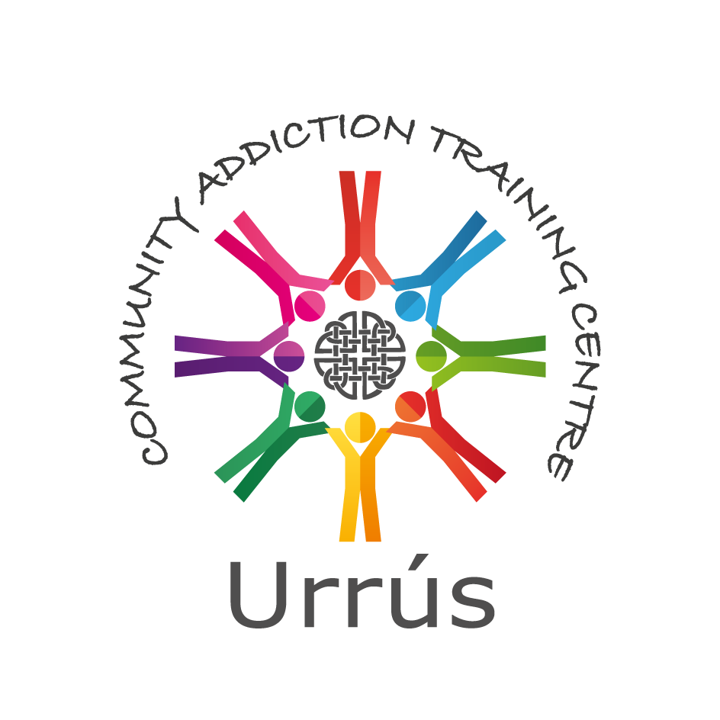

Horizons Centre, Balcurris Road, Ballymun, Dublin 11, D11 X2EP. Phone: 01 8467980 Fax: 01 8467981

Email: urrus@byap.ie Web: [www.byap.ie](http://www.byap.ie)

**Urrús Keyworking, Care Planning & Case Management QQI Award (Minor) Level 6**

Urrús Keyworking, Care Planning and Case Management programme will commence in September 2021. The programme is offered in response to the emerging skills, knowledge and practice needs of new and existing keyworkers in the drug and alcohol, homeless and broader social care sector. This programme will give learners the opportunity to understand the systems of key working, care planning and case management within the National Drug Rehabilitation Framework.

This programme is ideally delivered using face-to-face class activities; however, during the current pandemic the extent to which face-to-face class activities can take place will be limited and guided by Government advice. Therefore, for now the programme will be delivered in a blended learning format consisting of a combination of online sessions and real time class-based activities using either a virtual or classroom environment. It is essential that learners have computer and internet access to engage with the course learning. Prospective learners need to be available to engage in learning and study for the dates and times indicated.  Staff and learners are urged to exercise caution and continue to follow the public health guidelines rigorously.

# Aim of Programme

The programme will enable learners to:

* Develop the knowledge and understanding of the process of key working and acquire the skills and competencies necessary for key working.
* Develop knowledge and understanding of care planning and acquire the skills and competencies to develop, review and progress a care plan.
* Develop an enhanced understanding of case management concepts, frameworks and implementation methods.
* Develop an understanding of professional boundaries and potential boundary issues within the key working process.
* Gain increased knowledge of confidentiality within the key working and care planning process and to develop a greater understanding of the purpose and methods of case notes and record keeping.
* Develop a knowledge of the models of reflective practice and the application of reflection in the practice of key working and care planning.

**Duration:** This is a part-time programme delivered on Thursday (10am-5pm each day) over 12 weeks.

**Course Dates:** Thursdays 9th, 16th, 23rd, 30th, Sept., 7th, 14th, 21st, Oct., 4th, 11th, 18th, 25th, Nov. & 2nd Dec. 2021 / 10:00am-5:00pm

**Learner/Student Profile:** This training is for new or existing keyworkers, support workers and other practitioners in the drug and alcohol field and in the broader social care field. Applicants must have at least one level 5 module in addiction or in a related care sector field and be available to attend the programme as described above.

**Number of Learners/Students:** 16-22 per course*

**Application Procedure:** Applicants are required to complete an application form and attend an interview. Shortlisting may apply.

**Selection Procedure:** Learners are selected based on written application and interview. Appeals can be addressed to Urrús Co-ordinator.

**Certification:** Urrús is registered with QQI (Quality and Qualifications Ireland). On successful completion of the programme learners will receive a component certificate in Person Centred Planning (6N2206) QQI Level 6 and Boundary Management (6N2207) QQI Level 6. The programme is accredited as QQI Award (Minor) Level 6 - Further Education and Training.

As part of our quality assurance, the learners work is marked by a course tutor, checked and moderated by an internal verifier and an independent External Authenticator.

**NFQ Credit Value:** 30 Credits.

**Cost:** €595.

**Protection for Learners Policy:**

In the event that Urrús fails to provide the programme and certification as outlined above all payments will be refunded; financial policy and procedures available on request.

**Modules:** The modules covered during the programme are: -

* + - * Key Working – systems and processes
      * Care Planning – policy and practice
      * Case Management – framework and communications
      * Professional Boundaries – understanding and techniques
      * Confidentiality and Case Notes – guidelines and application
      * Reflective and Professional Practice – theories and practice

**Methods:** Delivery of the programme will see the use of inputs, group and individual exercises, role play, guided skills practice and reflective practice.

# Assessment: The assessment approaches used in the programme include written assignments and learning journals. Assessment is carried out throughout the course, as individual modules are completed.

**Progression Route:** The programme offers a progression pathway to the Level 7 Diploma in Community Drug and Alcohol Work delivered in partnership by Urrús and University College Dublin.

**Closing Date:** Closing date for completed applications is **Friday 20th August.** Interviews will be held shortly after closing date. If you have any further questions please contact the office – 01 8467980 / urrus@byap.ie

* A minimum of 16 participants are required for the course to run